Работа с видео «Love language»
(дополнительный материал к теме «Relations» по УМК М.З.Биболетовой – 9 класс)

***
Работа с видео на уроках английского достаточно эффективна для расширения словарного запаса детей, а также помогает восприятию аутентичной речи на слух.
Работа с видео предполагает различные этапы, начиная с этапа "Prediction" до просмотра видео, заканчивая этапом "Confirming prediction", а также "Language Study" (после просмотра видео)
Хотела бы предложить вашему вниманию этапы работы с видео на примере видео сюжета «Love language»

- Prediction
Please match a child and the main activity which is associated with him!

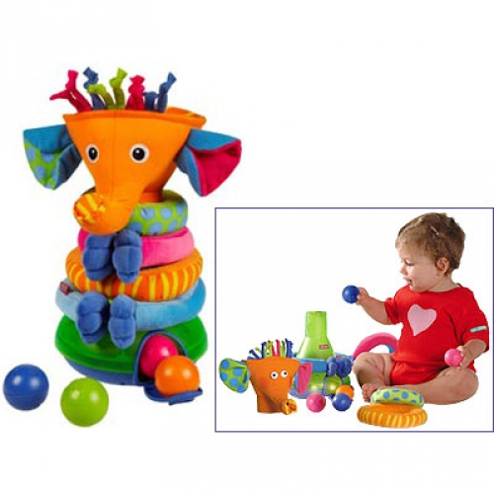
At the age of 3-5 the main activity for a child is playing games.


At the age of 7 a child starts his school life and it’s very important for him to study well at school.

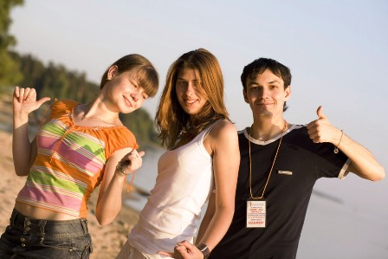
At the age of 15 a teenager feels that something has changed in his life – And the main thing for him or her is to communicate and make new friends, have new relations.

What is more important for you
- playing games, studying at school or warm relations with people near you?
- Watching Video/ Confirming Prediction
“LOVE LANGUAGE”
What is it associated with? – relations, studying, hobbies, spending time, words, talking, feelings… What is Love Language for you?

Well, let’s start. Do you like to watch videos? Let’s watch it.
But sometimes I will stop it and we’ll discuss some information together.
The 1st day – (просмотр видеофрагмента)
What are relations between a boy and a girl? (have no relations/ they have just met)
Did the boy like the girl or he just needed a pen?
The girl didn’t want to communicate with the boy, did she?
(she didn’t want to speak/ she wanted to listen to music)

The 2nd day – (просмотр видеофрагмента)
Why did the boy move closer to the girl? (he liked the girl and wanted to show his interest to her in this way)

What was her special song?
Why did she say NO?
What were the attempts to start a conversation?
What topics did the boy try to discuss?
Did they have positive communication?

The 3rd day –
Who made the 1st step in communicating on the 3rd day?
What did that mean?
She offered him to listen to her song, didn’t she? But she did it only on the 3rd day. Why?
What did the boy hear? What were the girl’s emotions at that moment?
She used manual alphabet. What does it mean? (deaf, dumb)

- Now watch the video fragment once again from the beginning to the end to feel the situation from inside!

- Language Study
What is LOVE LANGUAGE? Is it just talking warm words? Or … - Compare your first answers to this question at the beginning of our lesson and your feelings about this now.
Well, no doubt, spending time together is a way of communication for people. Do you think that watching TV or video is good or bad? Why? (It helps to think over our life and try to understand something very important)

